Excle Lab4 Assignment

HLOOKUP

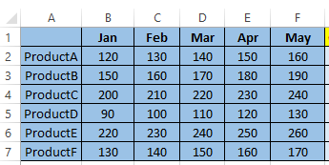

Use the Above data and perform the following task.

Q1.Use HLOOKUP to find the sales for Product A in March.

Ans: =HLOOKUP(D1,B1:F7,2,FALSE)

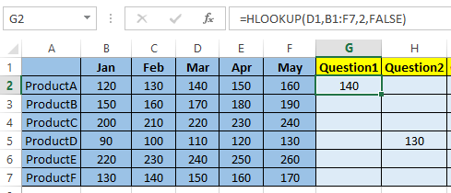

Q2. Use HLOOKUP to find the sales for Product D in May.

Ans: =HLOOKUP(F1,A1:F7,5,FALSE)

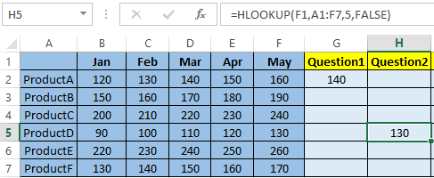

Q3. Use HLOOKUP to find the sales for Product C in February.

Ans: =HLOOKUP(C1,A1:G7,4,FALSE)

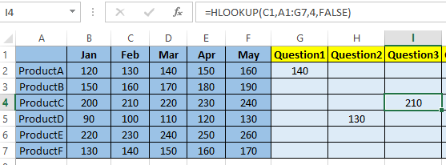

Q4. Use HLOOKUP to find the sales for each month for a product, then calculate the total sales for that product.

Ans: =SUM(HLOOKUP(B1, A1:F7, 2, FALSE),

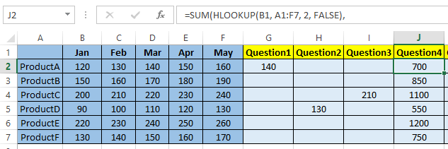

Q5. Use HLOOKUP to find the maximum sales value for Product B across all months.

Ans: =MAX(HLOOKUP("Jan",A1:F7,2,FALSE),HLOOKUP("Feb",A1:F7,2,FALSE),HLOOKUP("Mar",A1:F7,2,FALSE),HLOOKUP("Apr",A1:F7,2,FALSE),HLOOKUP("May",A1:F7,2,FALSE))

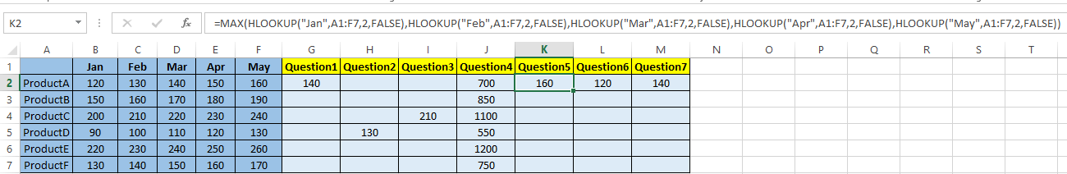

Q6. Use HLOOKUP to find the minimum sales value for Product F across all months.

Ans: =MIN(HLOOKUP("Jan",A1:F7,2,FALSE),HLOOKUP("Feb",A1:F7,2,FALSE),HLOOKUP("Mar",A1:F7,2,FALSE),HLOOKUP("Apr",A1:F7,2,FALSE),HLOOKUP("May",A1:F7,2,FALSE))

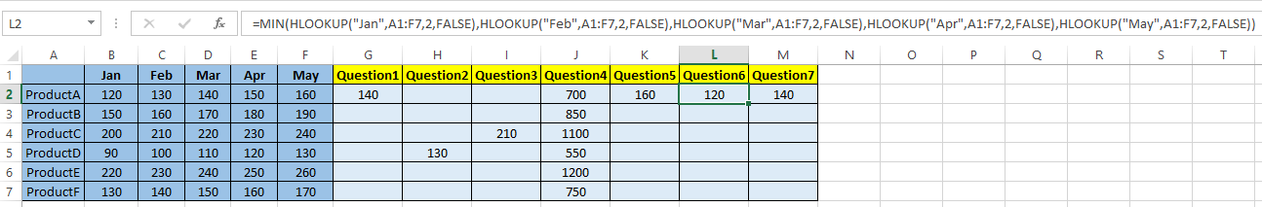

Q7. Use HLOOKUP to find the average sales value for Product E across all months.

Ans: =AVERAGE(HLOOKUP("Jan",A1:F7,2,FALSE),HLOOKUP("Feb",A1:F7,2,FALSE),HLOOKUP("Mar",A1:F7,2,FALSE),HLOOKUP("Apr",A1:F7,2,FALSE),HLOOKUP("May",A1:F7,2,FALSE))

